
MATHS METHODS (CAS) 3 & 4
TRIAL EXAMINATION 1
SOLUTIONS
2008

Question 1

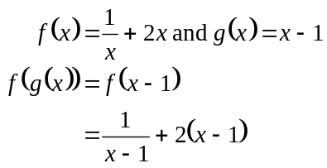
(1 mark)

Question 2

- 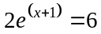
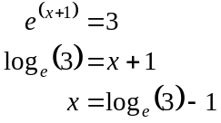
(1 mark)

b.
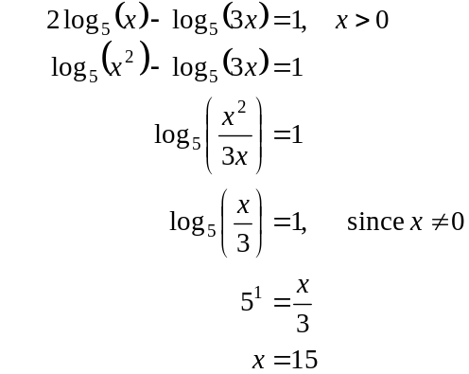
(1 mark)
(1 mark)

Question 3

a.
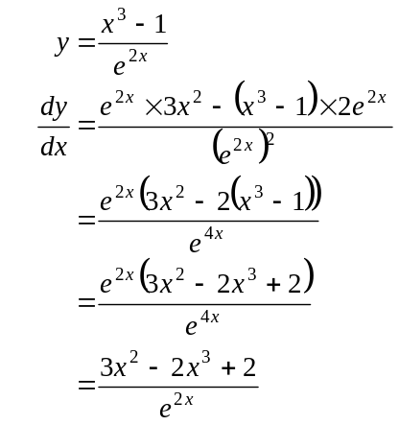
(Quotient rule)
(1 mark) –note that because the question is worth 1 mark and the question hasn’t asked for the simplification, the following lines are not required but are shown here to give an example of how you would go on to simplify if you were asked to

  - 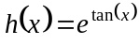
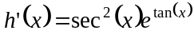 (Chain rule) (1 mark) correct derivative

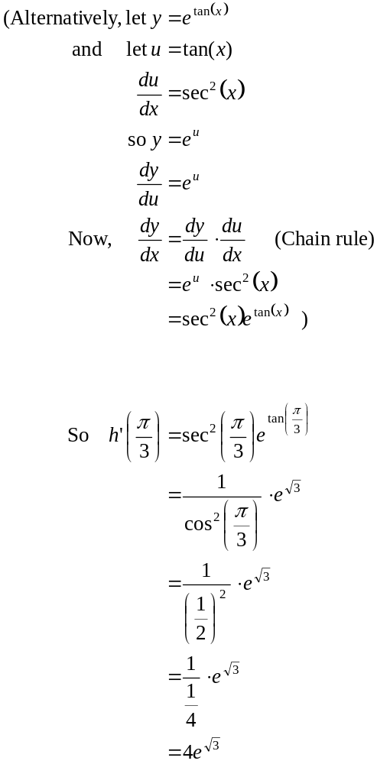
(1 mark) correct answer
Question 4
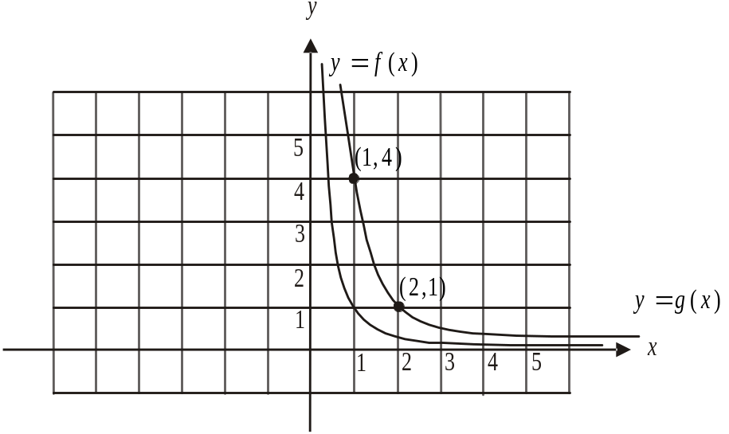
- i.

(1 mark) – correct graph of 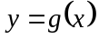 and labelling of two points
- Since the graph of 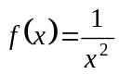 has been dilated by a factor of 2 from
the y-axis, we replace the x with to obtain the rule for 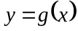.
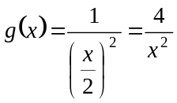 (1 mark)
b. i.
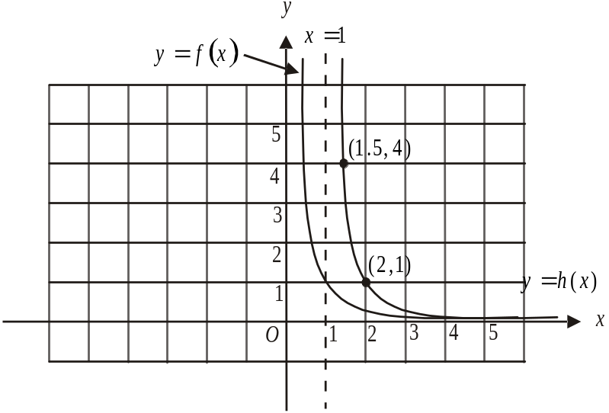

(1 mark) correct graph including 2 labelled points

ii. Equation of vertical asymptote is 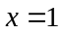. (1 mark)

iii. Equation of horizontal asymptote is 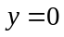. (1 mark)

iv. 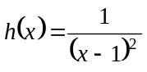 (1 mark)
Question 5

This is a binomial distribution with 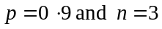.
Let X represent the number of females offered a scholarship this year.

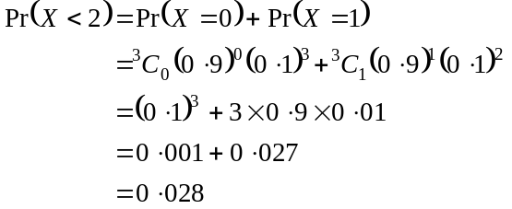
(1 mark)
(1 mark)

Question 6

X | 0 | 1 | 2 | 5 | 10
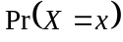 | 0.1 | a | 0.4 | b | 0.2

- Since X is a discrete random variable,
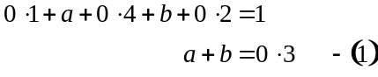
Also, since 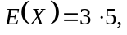
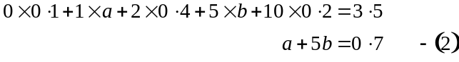
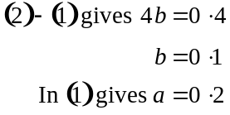
(1 mark) correct method attempted
(1 mark) correct answers

- The median of X is 2 because 50% of the distribution is greater than 2 and 50% is less than 2.
(1 mark)

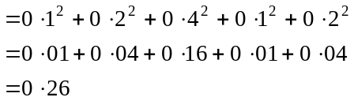
(1 mark)

Question 7
a.
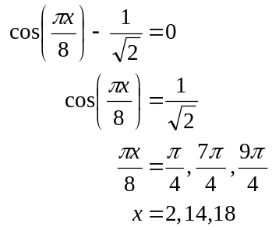
(1 mark)
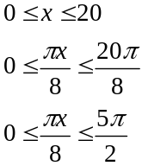
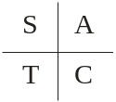
(1 mark)
- Method 1
The graph of 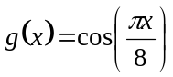 has maxima (for ) at 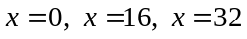 and so on because the period of the graph is given by 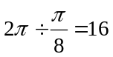.
The graph of 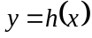 is the graph of that has been reflected in the x-axis translated 4 units to the left, and translated 1 unit down. (1 mark)
The graph of 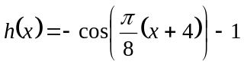 will therefore have minima at 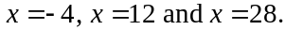 For 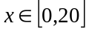 the required value of x is 12. (1 mark)

Method 2
The minimum occurs when 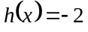 because the amplitude is 1 and there is a translation of 1 unit down.
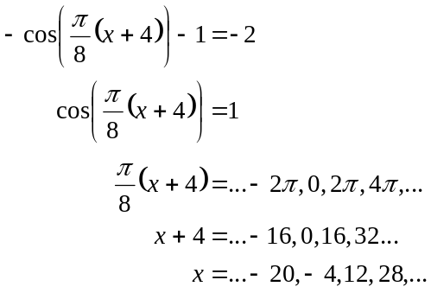
(1 mark)

For , . (1 mark)

Method 3
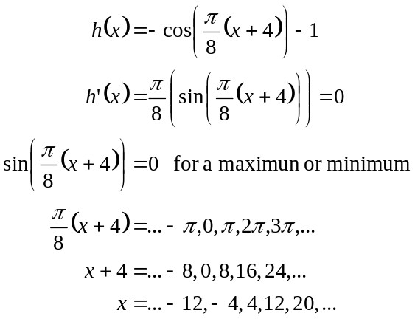
(1 mark)
At and at 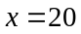there is a maximum.
At , there is a minimum. (1 mark)
Question 8

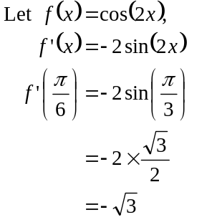
So the gradient of the tangent at 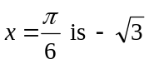. (1 mark)
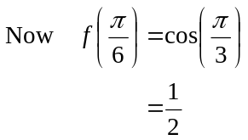
The tangent passes through the point 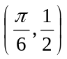.
Equation of tangent
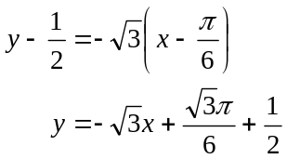
(1 mark)
Question 9

- 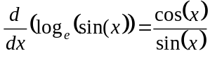
(1 mark)
- Hence 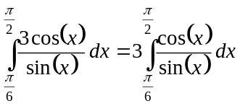
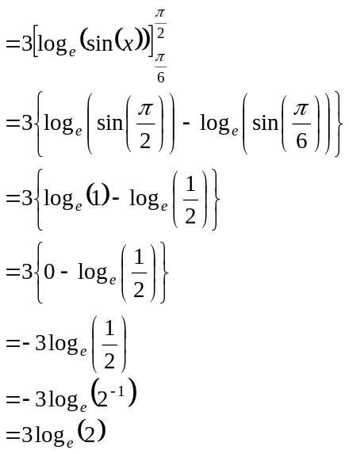
(1 mark)
(1 mark)
Question 10

The graphs of 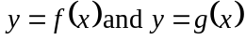 intersect when
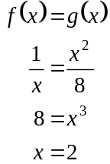

The graphs intersect when . (1 mark)

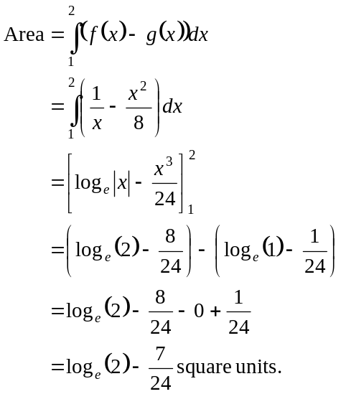
(1 mark)
(1 mark)
(1 mark)

Question 11

- Let 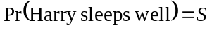
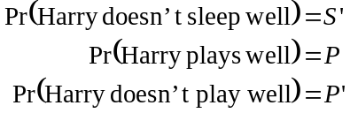
Using a tree diagram,
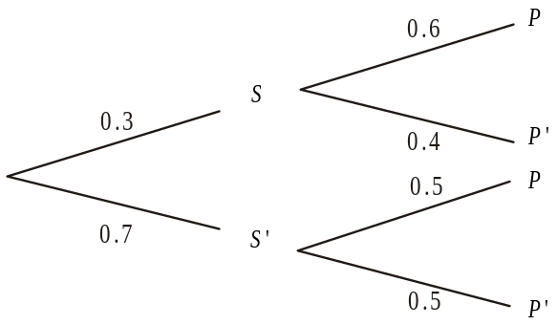

(1 mark)
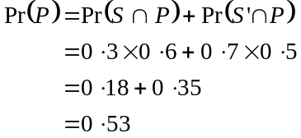
(1 mark)

b.
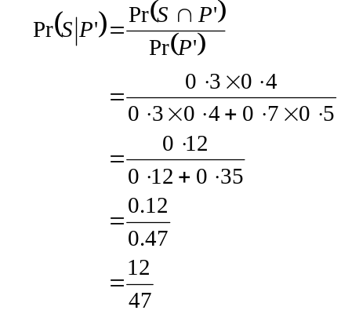
(1 mark)
(1 mark)
Question 12

- To show: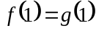; that is the graphs intersect at the point where .
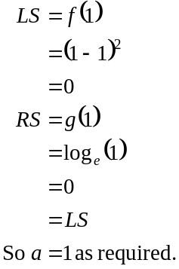
(1 mark)

- From the graph, 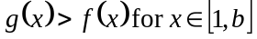.
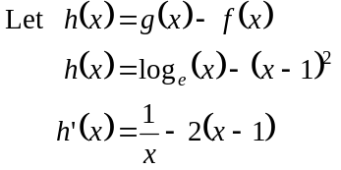
(1 mark)
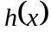 is a max/min when 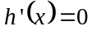.
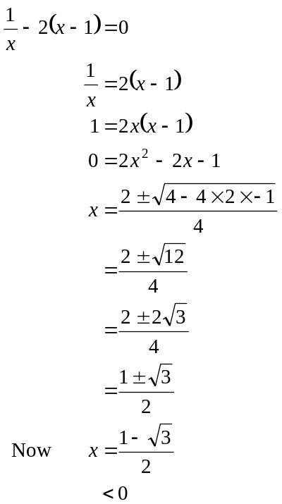
(1 mark)
Since this is outside the domain of 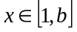 we reject this value of x.
So the maximum occurs at 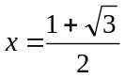.
(1 mark) including the rejection of 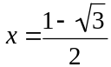

Total 40 marks

